Gitsit Fabric App: Pacific Private Money Bid Model
Nov 5, 2026

Overview
The Gitsit Fabric app recalculates the Pacific Private Money Excel model in the browser, from loans held in a Fabric SQL table, and saves the results and every edit back to Fabric. It replaces opening the workbook for each change: load loans, review the bid in the report pages, edit values for one or many loans, and everyone sees the same numbers.
Calculated totals match the workbook: total Bid 2,567,795.19 against Excel's 2,567,795.20. An earlier check found 40,050 of 40,054 loan-row cells matching Excel (99.99%).
Item | Value
Live app | good-larch-983338eded-centralindia.webapp.fabricapps.net
Fabric workspace | Gitsit_test
Fabric SQL database | gitsit-test
Sign-in | Microsoft Fabric account; the app is private
Project folder | GITSIT\Fabric apps\Gitsit_Test
Source workbooks | Pacific Private Money - input.xlsx, Pacific Private Money - model.xlsx (in Gitsit_Test\data)
Loans the model holds | 48 at most; 33 loaded today

How data flows
Input_table is the only starting point: the app builds everything else from it each time it opens.
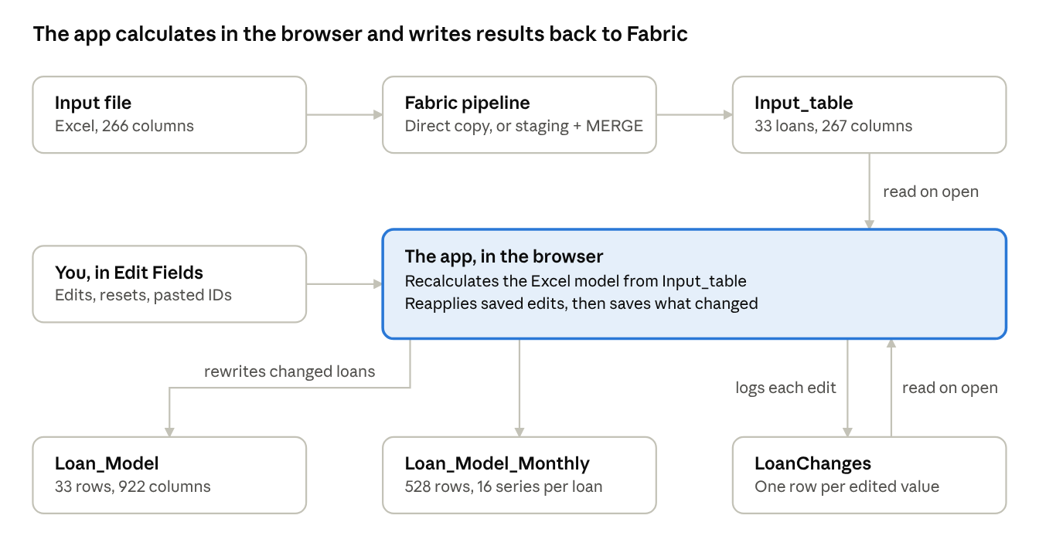
data flow · input file to the four Fabric tables
The app and the two model tables are kept in step by the browser, not by a scheduled job. LoanChanges runs both ways: each edit adds a row, and each open reads the rows back to reapply the latest edits.

Fabric SQL tables
Four tables in dbo hold everything, and they join on loan ID. All of them carry File_Name ("Pacific Private Money").
Table | Who writes it | Rows today | Columns | Key | What it holds
Input_table | Your pipeline | 33 | 267 | loan_id | The input file's 266 columns in file order, plus File_Name
Loan_Model | The app | 33 | 922 | loan_id | One row per loan: the Model sheet's one-value and date-history columns, in sheet order, plus changed_by, user_email, modifiedon, File_Name
Loan_Model_Monthly | The app | 528 | 40 | loan_id, series | The month-by-month blocks: one row per loan per series, months in m01–m36
LoanChanges | The app | Grows with each edit | 7 | File_Name, Loan_Id, Column_Name, Changed_On | One row per edited value; rows are only added, never rewritten

Where the Model sheet's 1,575 columns went
Every column that can hold a value is stored; all 1,213 named columns with formulas are included.
Model sheet columns | Count | Where
One value per loan, and date history | 918 | Loan_Model
Month by month | 564 | Loan_Model_Monthly
Always blank | 93 | Left out
The 93 left out have no formula, are not filled from the input file, cannot be edited, and are blank for every loan. They include the x separator columns, the String, CF Y/N and NDD+ Y/N history blocks, Loan ID 2 and Servicer ID.

Why the columns are split
Three limits decide the layout:
- A SQL table can have at most 1,024 columns.
- A Fabric connector can map at most 1,000 columns per table, and only one connector entity per table.
- A SQL row can hold at most 8,060 bytes. That is why Loan_Model stores numbers as FLOAT with row compression.

The 16 series in Loan_Model_Monthly
Group | Series | m01 means | Range
Cash-flow projection per exit scenario | Perf CF, Payoff CF, REO CF, NPL CF, CUSTOM CF, MATURING PERF CF, GNMA POOL CF, GNMA CLAIM CF | Month 1 (January 2026 in the current model) | Months 1–36
Payment history | CF$ | t-24 | t-24 to t-01 (m25–m36 empty)
Amortization schedule | Amo Pd #, Rate pct, P&I amount, Interest $, Principal $, Balance $, Prin Amo $ | t+1 | t+1 to t+36

LoanChanges columns
Column | Meaning | Example
File_Name | Source file of the loan | Pacific Private Money
Loan_Id | The loan edited | 2007403
Column_Name | The Loan_Model column changed | fade
Old_Value | Value before the change | -0.04
New_Value | Value after; a reset shows (reset) | -0.05, or -0.04 (reset)
User_mail | Who made the change | ashok.g@indium.tech
Changed_On | When, in UTC | 2026-10-29 08:56:18

Daily pipeline
A Fabric pipeline loads dbo.Input_table; Loan_Model and Loan_Model_Monthly follow the next time someone opens the app. Nothing recalculates in the background, because the calculation runs in the user's browser.

Set up the load
Use one of these two routes:
Route | When to use it | How
Direct copy | Simplest; the usual choice | Copy activity from the input file into dbo.Input_table, using table option Upsert on key loan_id, or truncate before load when each file is the full pool
Staging and MERGE | You want to check rows before they reach the app | Copy into dbo.Input_table_staging, then a Script activity runs the MERGE in docs/Input_table-merge.sql, which also creates the staging table
Column rules for the load:
- Map columns using docs/InputLoans-columns.md, which lists each input file header, its SQL column and its type. The file still uses the table's old name; the columns are the same.
- loan_id must be present and unique.
- File_Name is optional. Leave it out and it becomes "Pacific Private Money"; set it and that name carries to the loan's model rows and change-log entries.

What happens after a load
Change in Input_table | In the app | In Loan_Model and Loan_Model_Monthly
New loan | Included on next open | Rows added on next open
Changed value | Recalculated on next open | Affected loans rewritten on next open
Loan removed | Gone on next open | Rows removed on next open
Anyone with the app open is told about new data: it checks every 5 minutes and on returning to the tab, then offers a Reload button.
This was tested on 2026-10-27 with a test loan added to and removed from Input_table by SQL. A real pipeline run has not been tested yet.

Using the app
The app follows the layout of the GITSITFINAL Power BI report and adds Edit Fields for changing values on many loans at once. Edits are shared: everyone who opens the app sees them.
Page group | Pages
Start | Home Page
Distributions | Seller Value; Seller Value & Total UPB; Total UPB; Asset Value; Asset Value ($mm); LTV; DTV; Months DQ; Months Seasoned from Orig/Mod; Rate; P&I; Origination Year; Payers Current YTM
Analysis | Bid Summary; Pool Stratification; Exit Scenarios; Pool Mix & Credit; Loan Detail
Settings and edits | Assumptions; Edit Fields
The side panel also shows the save status (for example "Saved to Fabric at 02:26 PM"), Your changes with a count, Reset all, and Export to Excel. Reset all removes the saved edits for everyone, so use it with care.

Change many loans in Edit Fields
- Open Edit Fields.
- Under 1. Select loans (WHERE), set Field to Loan ID and Operator to is one of.
- Tick loans in Values, or paste a list into Or paste a list and click Add pasted. Paste IDs one per line, as copied from an Excel column, or separated by commas, semicolons or tabs.
- Check the note: it says how many were added and names any IDs not found. Leading zeros do not matter, so 0002007403 matches 2007403.
- Under 2. Set values (SET), pick the Field, the Action and the Value. Use Add field to change more than one field.
- Read the statement preview, then click Apply to N loans.
- Wait for the save status to show Saved to Fabric.
Conditions are not limited to Loan ID. Any report field works, with is one of, contains, =, between, is blank and similar operators, and a loan must meet every condition.
Action | What it does | Example
set to | Replaces the value. Percent fields take percentages. | 25 means 25%
add | Adds to the current value | 1500
change by % | Scales the current value | 10 means +10%
reset to model value | Removes the edit and returns to the model's calculation

Fields you can edit
There are 35 editable fields:
Group | Fields
Balances and value | Arrearage, BPO As-Is, Fade, Faded Value, Is EPD
Exit probabilities | p(CF), p(Payoff), p(REO)
Hurdles and results | Hurdle NPL, Hurdle Yield, Bid, Gross Proceeds, LL Exp/Inc, Months, RPL Type
Payoff expenses | Payoff T&I Exp, Payoff FCL Exp, Payoff PPRES Exp
REO expenses | REO T&I Exp, REO FCL Exp, REO PPRES Exp, REO Fwd Arrears, REO Fwd Total, REO Rehab Exp, REO Utilities Exp, REO Eviction Exp, REO Broker Exp, REO Closing Exp
NPL expenses | NPL T&I Exp, NPL FCL Exp, NPL PPRES Exp
Custom scenario | Custom Exit %, Custom Capex %, Custom Timeline, Custom Return

Read the change log
Each edit adds one row per loan and column to LoanChanges. A change that leaves the value as it was is not logged.
SELECT [Loan_Id], [Column_Name], [Old_Value], [New_Value], [User_mail], [Changed_On]
FROM dbo.LoanChanges
ORDER BY [Changed_On] DESC;
The app reapplies the latest change for each loan and column when it opens, unless that change was a reset. A reset is marked (reset) in New_Value so the loan follows the model again, even if the calculated value later moves.

Maintaining the app
Most changes are one file followed by a deploy; only a change to the workbooks' columns also needs database work. Paths below are under Gitsit_Test\packages\frontend\src unless they say otherwise.
To change | Edit
Colors | global.css: the light theme is near lines 49–66, dark near 198–211 (--color-banner, --color-action, --color-title, --color-canvas, --color-series-1 to 4)
Logo | Replace assets/gitsit-logo.jpg, keeping the file name
Page title | packages/frontend/index.html
Pages, cards, charts, slicers | report/pages.tsx
Measures such as Bid % and MOIC | report/measures.ts
Edit Fields | report/edit-fields.tsx
How data is saved | store/shared-model.ts

Run it locally
The local app writes to the same Fabric tables as the live app, so edits made locally are real. Set Node for that terminal only; do not change the system PATH.
$env:Path = "$env:LOCALAPPDATA\Programs\node-v24.22.1-win-x64;$env:Path"
npm run -w @rayfin-app/frontend dev
Then open http://localhost:5173.

Check and deploy
Run these from Gitsit_Test, with the local server stopped because it can lock files the deploy needs:
npm run typecheck
npm run build
npm run lint
npm test
npx rayfin up -n --workspace "Gitsit_test"
npx rayfin up --workspace "Gitsit_test"
The -n run is a preview that changes nothing. Read it before running the real deploy.

When a workbook's columns change
Replacing the Excel files is not enough on its own, because the tables and the app are generated from them.
- Replace the files in Gitsit_Test\data, keeping their names.
- In packages\frontend, run node scripts/gen-store.ts, then npm run build:model, then node scripts/gen-store.ts again.
- Update the tables in Fabric. docs/setup-database.sql only creates tables that do not exist, so added or removed columns need ALTER TABLE by hand.
- From Gitsit_Test, refresh the connector: npx rayfin connector remove gitsitdb --yes, then npx rayfin connector add --type fabric-sqldatabase --workspace-id 0efa0e7c-fc28-4492-9572-a7a069c679ab --item-id e40f6906-4431-48db-8eca-33c1fd246d16 --name gitsitdb.
- In packages\frontend, run node scripts/gen-connector.ts.
- Check and deploy as above.
New rows with the same columns need none of this: they only need the pipeline.

Known limits and troubleshooting
The limit most likely to matter next is capacity: the model holds 48 loans, and 33 are loaded today.

Limits
- 48 loans at most. The model sheet has rows 11–58 for loans. Extra loans are left out of the calculation and the app names them in a banner. Raising this means extending the Excel model.
- Model tables update only when the app is opened. After a pipeline load, Loan_Model is out of date until someone signed in opens the app.
- Loan_Model is not the whole sheet. Month-by-month columns are in Loan_Model_Monthly, and 93 always-blank columns are left out.
- Text is stored up to 400 characters per column.
- File_Name position. It is the first column in LoanChanges and the last in the other three tables.

Troubleshooting
What you see | Likely cause | Fix
"No connectors are declared in project settings" | The connector setting was cleared; running npm run dev or start-local.cmd appeared to do this | Run npx rayfin up --workspace "Gitsit_test", and run locally with the command in Run it locally
"Couldn't read the input loans from Fabric", with bundled data showing | The app cannot reach Input_table | Read the message in the banner; check the table exists and the connector is deployed
"Not saved to Fabric: GraphQL errors: An internal execution error occured" | The database refused a write, for example a row over 8,060 bytes | Check the table's types match docs/setup-database.sql, and test the write in the SQL editor to see the real error
"Input_table has N loans but the model holds 48" | More than 48 loans loaded | Remove loans or extend the Excel model
Sign-in stuck on "Please allow pop-ups" | The browser blocked the sign-in popup | Allow pop-ups, or sign in from your normal browser
Deploy: "FieldMappings size cannot be greater than 1000" | A table has more than 1,000 columns | Move columns out of the table
Deploy: "The built bundle is not parseable JavaScript" | Connector entity classes reached the browser bundle | In lib/connectors.ts, import only types from the connector schema
Deploy: "unknown error, unlink ... rayfin.tsbuildinfo" | The local server has the file open | Stop the local server and deploy again

